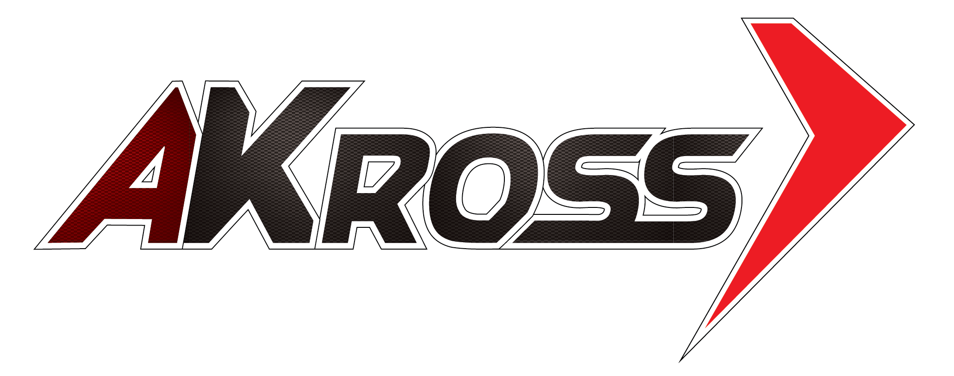 | AKross Premium Progress 5W-40 SL/CF

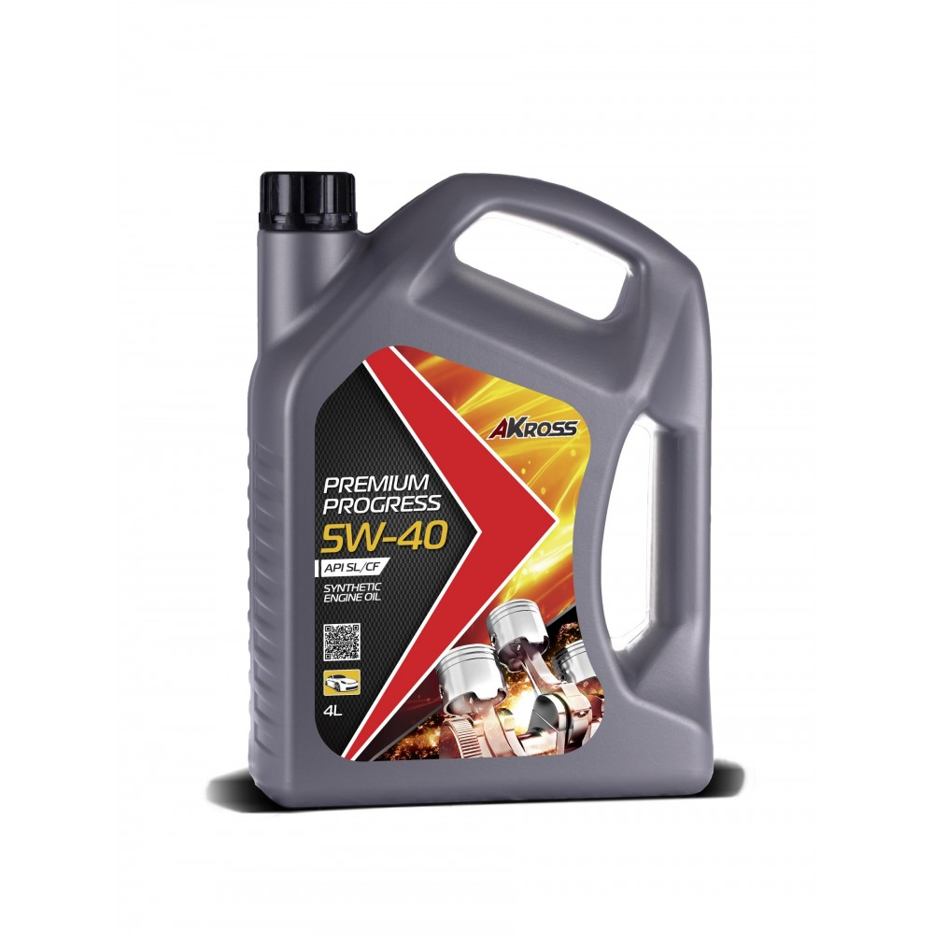 | PERFORMANCES LEVELS  API SL/CF  SAE 5W-40  ACEA A3/B4  DESCRIPTION  AKross Premium Progress 5w 40 SL/CF is a universal, multigrade, syntatic oil. It is made on a high-quality syntatic base oil and multifunctional foreign addictives.  The oil possesses stable viscosity and temperature properties that protect engine from wear and corrosion.

APPLICATIONS
The motor oil AKross PREMIUM PROGRESS 5W-30 SL/CF is intended for modern high-performace gasoline and diesel engines of cars, trucks, vans, that require the use of API SL/CF lubricants.
PACKAGING
All products are produced in plastic canisters 1L, 4L, 5L and in steel barrels 205L.
PROPERTIES AND SPECIFICATIONS
Properties | Method | Value
Kinematic Viscosity at 100°С, mm²/s | ASTM D445 | 14,0
Viscosity Index | ASTM D97 | 168
Flash Point, °С | ASTM D92 | 211
Density at 20°С, kg/m³ | ASTM D 1298 | 856
Pour Point, °С | ASTM D97 | -37
Perchloric acid, mg KOH/g | ASTM D4739 | 6,5
Sulphated ash, wt % | ASTM D874 | 1,2
The features mentioned above are average values obtained with some variability in production and do not constitute a specification.

